**Tableau Major Assignment**

Question 1 - Create the dashboard with following the general requirements in the dashboard following sheets required

1.First sheet should have total discount, profit, quantity and sales (KPI format preferred means only number- no chart).

2.Second sheet shows monthly sales per year.

3.Third sheet shows monthly profit per year.

Answer - <https://public.tableau.com/views/MAJORASSIGNMENTTABLEAU/Dashboard1?:language=en-US&:display_count=n&:origin=viz_share_link>

Question 2 - Answer the following

1.Top 5 cities which bears maximum loss

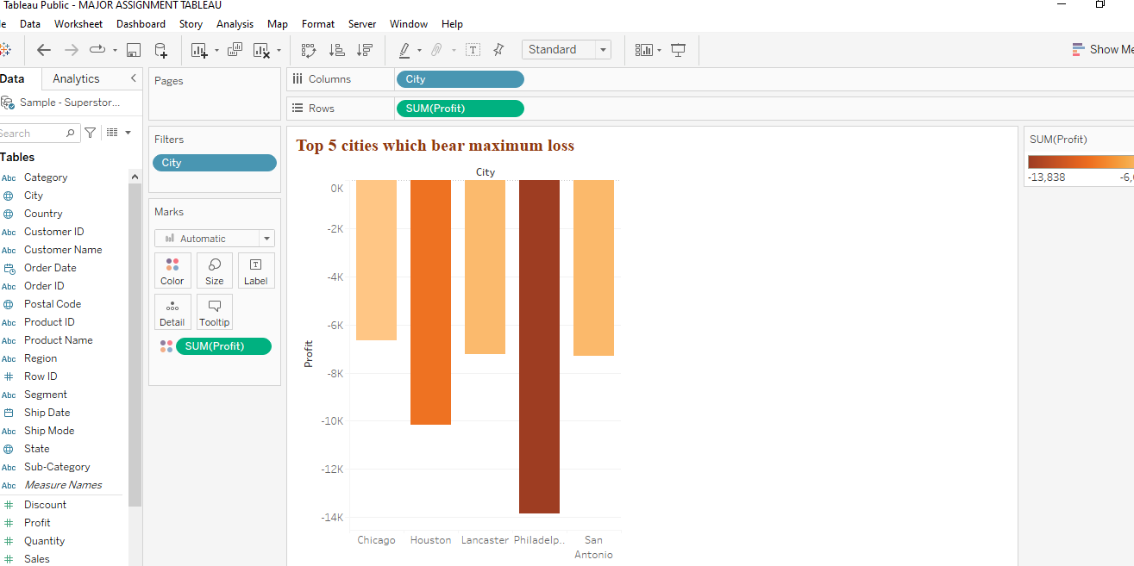

1. Philadelphia 2. Houston 3. San Antonio 4. Lancaster 5. Chicago

2.Which is the region with highest sales

Answer – West Region has the highest sales.

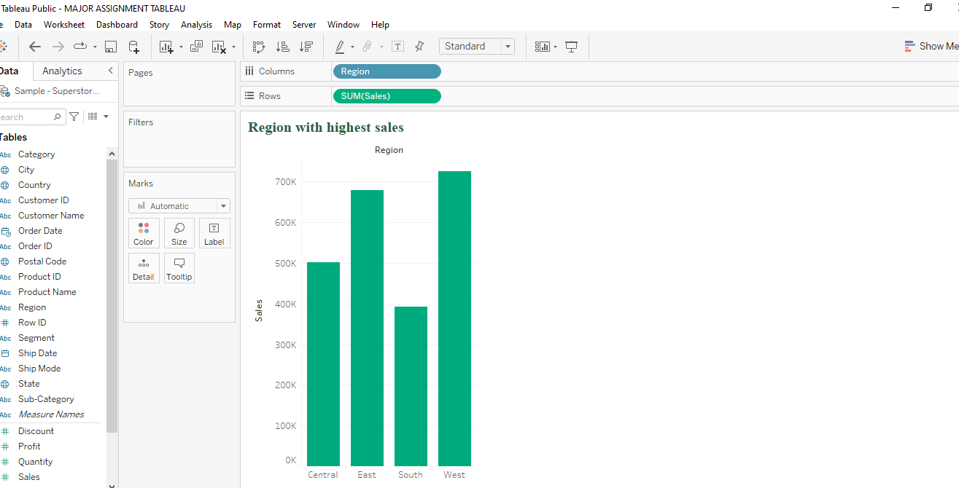

3.Name category in region with highest sales

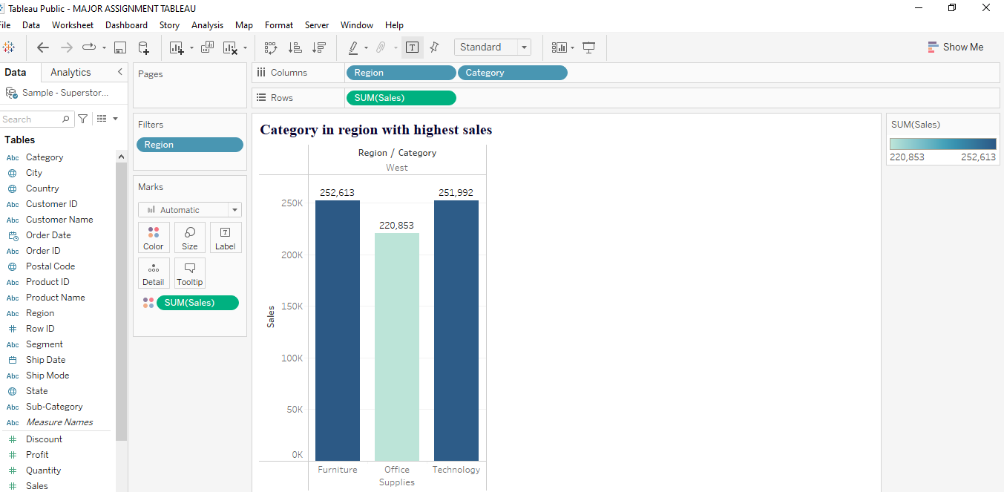

4.Which state has highest quantity of orders

Answer – California

